Guidance Notes for Main Exhibition

Public Artists

The following information gives everything you need to know about exhibiting your work at the main exhibition of Holmfirth Artweek.
Please read this to get all important dates and information on how to label correctly to ensure a smooth process and prompt payment.

Exhibition Number
The exhibition number is a unique number we use to identify each artist, which helps our record keeping and ensures each artist is paid the correct amount. Your exhibition number will be asked for when submitting information and should go on every piece of work you bring to the main exhibition, whether they are the main artworks, pieces for the market or demonstrators’ stage.

When you registered for Artweek you will have received a confirmation email that gives an order number that looks like: Order #AW26-000 (date you applied)
The final 3 digits of this are your exhibition number (in this example 000).
Please check your registration confirmation email to get your number (your number is NOT 000). If you can’t find this, email info@holmfirthartweek.org.uk to get your exhibition number.

Main Exhibition Pieces
Details of your main exhibition pieces must be submitted before 1st June.
The link to submit the details is on your registration confirmation email, if you can’t find this, please email info@holmfirthartweek.org.uk

Public artists (those who applied without an invitation email) can submit 2 pieces to the main exhibition.
- The work must be original to the artist
- The pieces must not be reproduction prints of originals, we only allow original prints such as screenprints, linocut prints, photography and prints of original digital artwork (no AI generated please), in the main exhibition.
- The work must not have been shown in a previous Holmfirth Artweek.
- The items must be for sale, with a minimum price of £30.

All work must be delivered to Artweek in a presentable standard.
For wall pieces, this means they must be ready to hang (with string or wire across the back, not clip frames or picture frame/mirror plates unless very heavy).
2D work on surfaces like paper and canvas boards must be framed, stretched canvases do not require framing. The better your work is framed, the more chance it will have of selling.
We reserve the right not to exhibit any artworks that are poorly presented.

All work must remain on display in the exhibition until 5pm on the closing Saturday.
20% commission will be taken off the price of all work sold for our charities (Macmillan Cancer Support and the Kirkwood). If you wish to donate a larger percent, please email info@holmfirthartweek.org.uk to let us know.

Taking In Day
Artwork for the main exhibition must be delivered to The Civic, Huddersfield Road, Holmfirth. HD9 3AS on Sunday 28th June, between 3pm and 6pm.

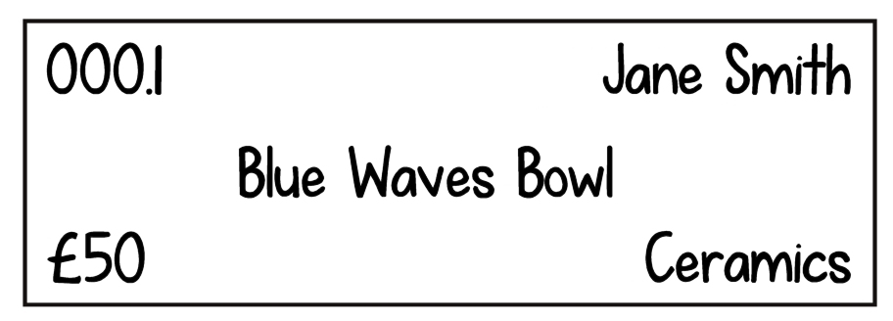
Your work for the main exhibition must be labelled with your exhibition number & piece number (1 or 2), your name, the title, price and medium of the piece.

For 3D work, this label should be on the base.
For 2D work, this label should be on the back, with a second label showing the same information on a string which is tied to the back but long enough to hang over the front. 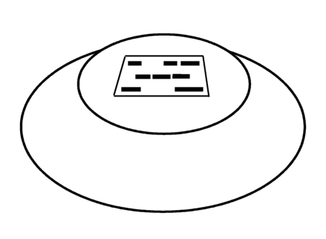 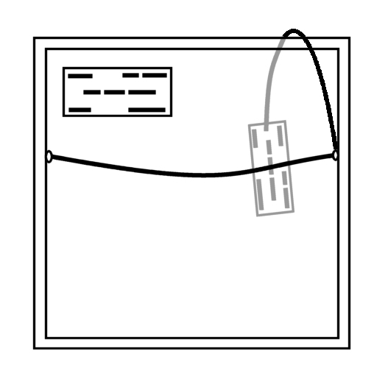
You may want to wrap/cover your work when bringing it in if the weather is bad, as the queue may stretch outside during busy times.
When you arrive your work will need to be checked in by our volunteers, it will need to be unwrapped at this point for the labels to be checked.
Once your work is checked in you will be told which area to leave it in. It may be moved from this point, so don’t worry if you can’t find it in the same place when you later visit (the sales desk will be able to tell you which bay it is in, if you ask once the exhibition is open).
Please take any wrapping with you when you leave.

If you can’t bring your work at the allocated time and are unable to get anyone else to bring it for you, please contact info@holmfirthartweek.org.uk before Taking In day.

Market
All artists exhibiting in the main exhibition are welcome to bring additional work (such as cards, prints, seconds and small originals) for our Market on the stage of the second floor.
Items on the Market can be bought and taken away immediately, and are sold by our team of Market volunteers (artists do not need to be there to sell the work).

Please be aware that space on the Market is very limited.
If you have display equipment you can bring it - those that make efficient use of a small space are best, however we can’t guarantee that we will use it, or if we do it may also display the work of others, not exclusively your own work.
We aim to display a selection of work from every artist that brings work for the market, but if you bring a lot we can’t guarantee all of the work you bring will be on display.
If there is more than we can fit on display, the extra work will be stored out of sight to top up as work sells.
Because of this it is good to bring work for the Market in a box/bag, and make sure delicate items are adequately wrapped for protection during storage.
Please make sure any boxes, bags or display equipment you bring are labelled with your exhibition number, so we can make sure they come back to the right person at the end of the exhibition.

All work for the Market should be individually labelled with your exhibition number, price and name.
If you have an offer on your items, such as 3 cards for £5, this must be written on every eligible item.
Items on the Market must have a minimum price of £1, and all prices must be in whole pounds (no £1.50 or £9.99).

Items for the Market should be brought on Taking In day along with your main exhibition pieces. Market items don’t need checking in with the main pieces, but should be taken to the stage on the second floor and left with the Market volunteers.
Please include an inventory sheet with your name, exhibition number and a list of what items you’ve brought for the Market (this doesn’t need to be overly detailed, eg 20 cards - £3, 5 A4 prints - £15). You can download a sheet from the website.

If your work on the Market is popular and looks like it may sell out quickly, the Market team will contact you to see if you can bring more during the week.

Collection
All unsold work from the main exhibition and market should be collected on Saturday 11th July between 6pm and 9pm.
All items bought in the exhibition can also be collected during this time.

We aim to contact artists who have sold all of their pieces before the end of Artweek (although this may not always be possible for a last minute sale on the final day), so if you have not heard from Artweek, you should come to collect.

Please bring your receipt to collect your work (you will receive this on Taking In day). If you’re unable to collect yourself, you can give a friend or family member your receipt to pick up for you.

If you will be unable to collect during this time, please contact info@holmfirthartweek.org.uk to let us know. The Civic will be cleared of all things Artweek the morning after we close, which means we are unable to store any work here.

Payment
We aim to pay artists for all work sold within 30 days of the close of the exhibition by bank transfer. All Exhibition sales will be paid out first, then Market sales, then Demonstrating sales, as appropriate.

If you have not sold before at Artweek or have changed bank accounts, please fill in a bank details form on Taking In day or during the exhibition (available at the Sales desk), or email the details to the treasurer at: holmfirthartweek@gmail.com

If the name you are exhibiting under and your bank account name are different, please make this clear to us when you give us your information.

If you do not supply your bank details we cannot pay you.
Any queries regarding payments must be raised by 31st July.

Important Artweek Dates 2026
31st March - Invited Artist Application Closing Date
1st April - Public Artist Applications Open
When sold out or 30th April Public Applications Close
1st June - Artwork Details Deadline (all artists)
28th June - Taking In Day
1st July - 3D Artists with a Table Taking In
4th July - Preview for Friends of Artweek
5th July - 11th July Artweek Open
11th July 6-9pm - Unsold Artwork Collection

If there are still any questions you have that this guidance doesn’t answer, please get in contact with info@holmfirthartweek.org.uk

Thank you for exhibiting with us.

